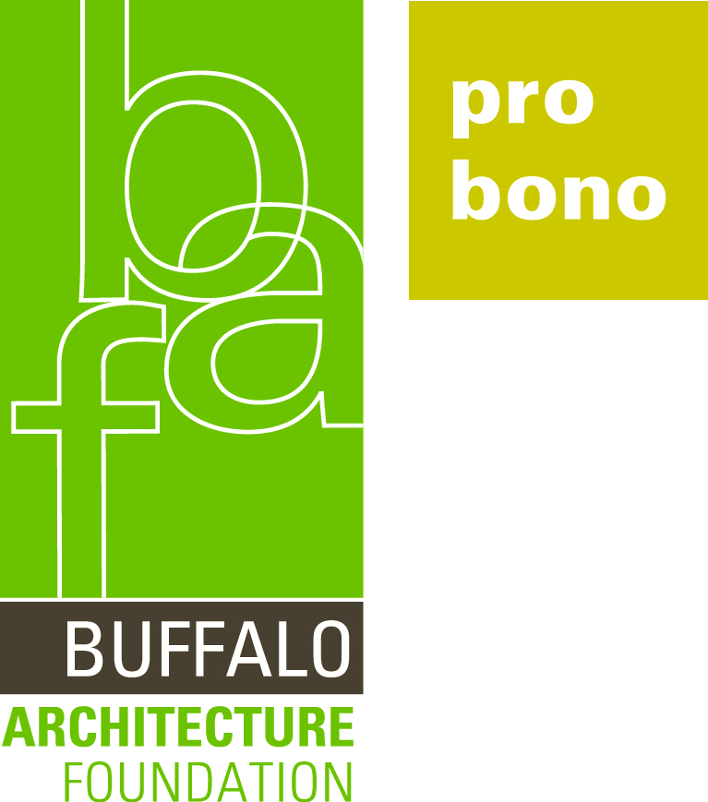 |  | 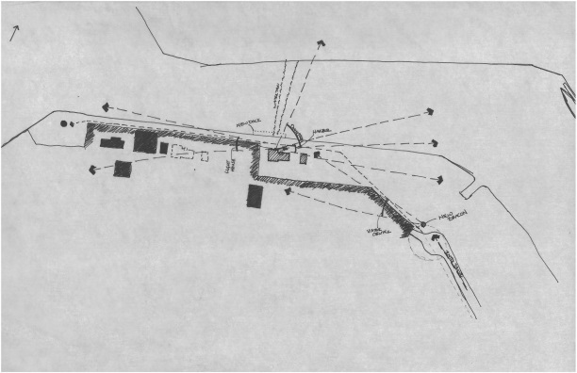

Buffalo Architecture Foundation (BAF) is pleased to announce Flynn Battaglia Architects as the recipient of the Pro Bono Publico Award in Distinguished Service for their notable ongoing commitment to the Buffalo Lighthouse Visitor Center project. This award recognizes exemplary pro bono services, rendered in the public interest without fee or with a significant reduction in fees, provided to not-for-profit clients.

The Buffalo Lighthouse Association (BLA), stewards some of the oldest surviving examples of public architecture in the city--the 1833 Buffalo Lighthouse and the 1903 South Buffalo Lighthouse. A gem of the region’s maritime heritage, the 1833 Buffalo Lighthouse is listed on the National Register of Historic Places and is also a designated City of Buffalo, Niagara Frontier and American Civil Engineering landmark.

Since the 1833 Buffalo Lighthouse accommodates tour group of limited size, BLA approached Flynn Battaglia Architects and the University at Buffalo’s Senemut Chapter of the Alpha Rho Chi professional architecture co-educational fraternity to envision a new Buffalo Lighthouse Visitor Center.

The Flynn Battaglia team of Principal Peter Flynn, AIA, Preservation Leader Michael Lennon, AIA, Design Leader Christopher Less, AIA and Architectural Planner Courtney Creenan-Chorley, Associate AIA mentored and collaborated with the fraternity students to study precedents, develop a concept design and establish site strategies. The new visitor center is planned to be located near the site of the 1905 U.S. Lifesaving Service Station at Lighthouse Point in the Outer Harbor. Referencing the footprint and form of the original wood-shingled building while expressing a modern, transparent aesthetic, the illuminated cultural venue will offer strategic connecting views to the lighthouse, the Buffalo River, Lake Erie and downtown Buffalo. Influenced by rescue boats, the interior shell of the exhibit hall will be clad in warm wood with rugged cast iron fittings.

The Buffalo Lighthouse Visitor Center and related site improvements will support the 1833 Buffalo Lighthouse by enriching the visitor experience with a tour staging area, a museum for artifacts, unique indoor event space and outdoor gathering places. BLA President Michael N. Vogel praises Flynn Battaglia for working closely with the organization to meet the project goals magnificently. The pro bono design work will enable BLA to share their vision with the Coast Guard, the State Historic Preservation Office and funding agencies as they pursue this long-term project.

Celebrating its 25th anniversary this year, Flynn Battaglia Architects proactively imparts a firm-wide philosophy that providing pro bono services affords their staff rewarding opportunities to connect with passionate individuals undertaking projects at the grass roots level and to provide guidance along a path to the end goal.

BAF applauds the Citizen Architects of Flynn Battaglia for their important contribution to preserving the past and building the future of the Buffalo Waterfront.

